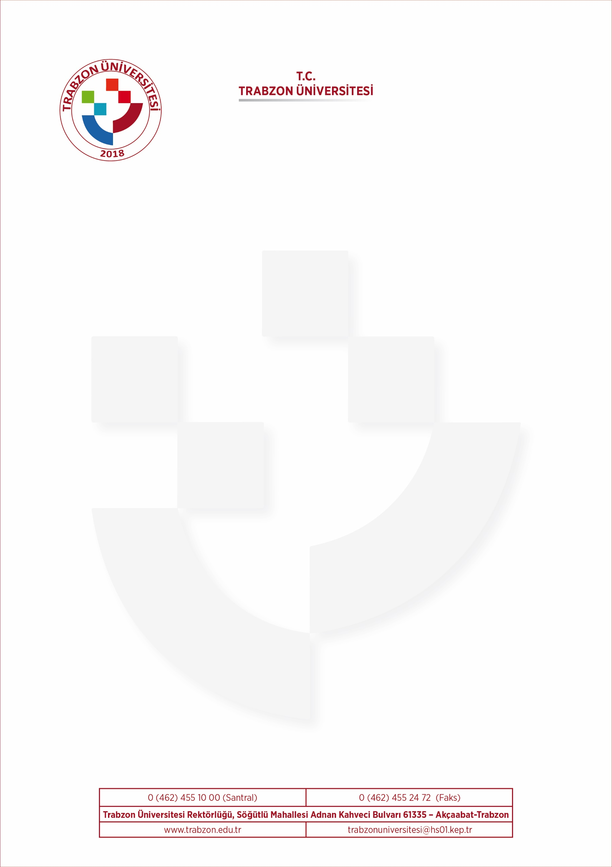

CERTIFICATE OF ATTENDANCE

Erasmus+ Student Mobility for Studies (SMS)

This is to certify that

a registered student of
TRABZON UNIVERSITY (TR TRABZON 04)
participated and successfuly completed a period of Erasmus + student mobility at Department of University
beetween … / … / ….. and … / … / …..
within the framework of ERASMUS+ Student Mobility for Studies (SMS) and in accordance with the Learning Agreement
between the student, the host HEI, and the home prior to the mobility period.

Signature and stamp

Name of Signatory:
Function:

