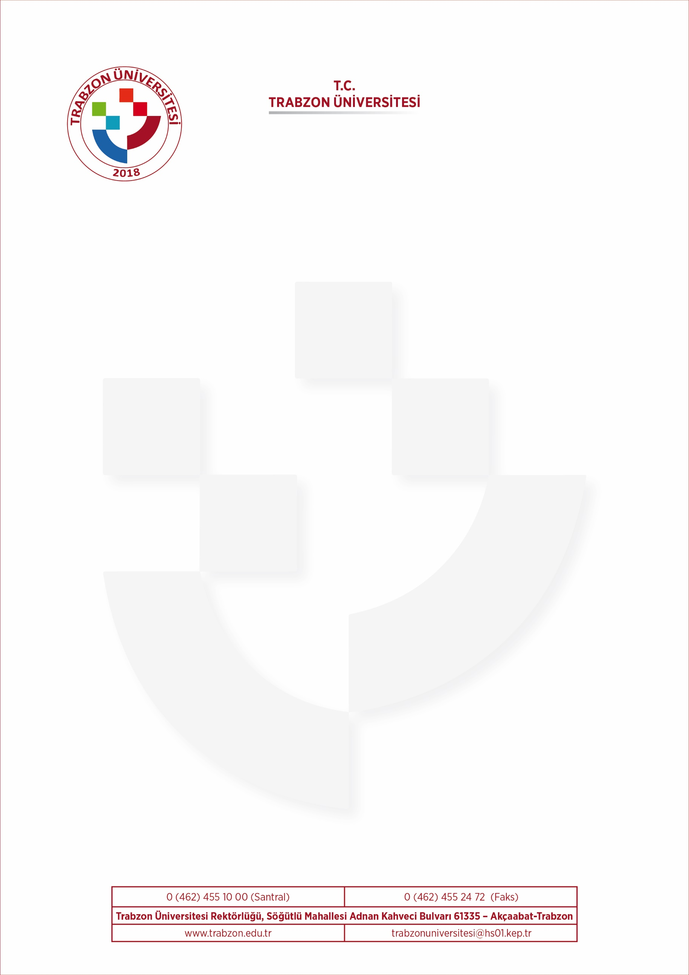
To Whom It May Concern

………………………………., whose personal particulars are listed below has performed successfully in the English Language Proficiency exam for the candidates of Erasmus+ Programme at the ………………………………. Department of Trabzon University, for ….. - ….. Academic Year.
He / She received ….. / 100 from the written examination and yet another ….. / 100 from the speaking section. His / Her final language grade is ….. / 100 in consequence of the written and interview examination with a percentage of 75% from the former, and 25% from the latter.
I hereby confirm to my capacity as the Institutional Erasmus+ Coordinator that ……………………………….,s English language proficiency is equal to the ….. Level of Common European Framework of References for Language required by your institution. This document was given at the request of the student.
Best regards,

Date:
Signature:

